Experiment 2: Case Study

Name: N Charitha Reddy
Roll No: 2420030425
Problem Statement: Identify an appropriate real-world case study, select a suitable software development process model and programming language, and propose an implementation and evaluation strategy.

1. Functional Requirements
Customer
The E-Commerce Platform should allow customers to:
- Register and login securely
- View and update their profile
- Browse, search and filter products by category
- View product details, images and specifications
- Add products to cart and wishlist
- Place, track and cancel orders
- Pay for orders online securely
- Receive order and delivery notifications
- Access order history and invoices
- Download invoices and return/exchange labels
- Submit product reviews and ratings
- Raise support tickets
Seller
The system should allow sellers to:
- Login securely
- View assigned and upcoming orders
- View customer order history
- List and manage product catalog
- Update product pricing and stock electronically
- Process and review return and refund requests
- Provide customer chat support
- Upload shipping and delivery updates
- Manage store schedule and promotions
Administrator
The administrator should be able to:
- Manage customer records
- Manage seller and staff records
- Manage categories and product listings
- Manage billing and payment gateway details
- Manage warehouse and inventory
- Manage shipment and delivery allocation
- Manage return and refund records
- Manage support tickets
- Generate reports

2. User Stories
User ID | User Story | Priority
US-01 | As a customer, I want to register and login securely so that I can access shopping services. | High
US-02 | As a customer, I want to place, track, or cancel orders so that I can manage my purchases. | High
US-03 | As a customer, I want to view product categories and details so that I can select a suitable product. | High
US-04 | As a customer, I want to access my order history and invoices so that I can track my purchases. | High
US-05 | As a customer, I want to view shipment tracking status online so that I can access my delivery updates easily. | Medium
US-06 | As a customer, I want to receive order and delivery reminders so that I do not miss them. | Medium
US-07 | As a seller, I want to view customer order history so that I can make informed business decisions. | High
US-08 | As a seller, I want to manage product listings and process orders electronically so that inventory records remain updated. | High
US-09 | As a seller, I want to manage my store schedule and promotions so that customers can view my offers. | Medium
US-10 | As an administrator, I want to manage customer and seller records so that platform information remains accurate. | High
US-11 | As an administrator, I want to manage billing and payments so that financial transactions are properly recorded. | High
US-12 | As an administrator, I want to generate reports so that platform activities can be monitored and analyzed. | Medium

3. Selected Software Development Process Model
Agile Scrum
Reason for Selection
Agile Scrum is suitable for the E-Commerce Platform because:
- The system contains many independent modules.
- Requirements may change based on market trends and customer demand.
- New modules can be developed incrementally.
- Customers, sellers, and administrators can provide continuous feedback.
- Critical bugs affecting checkout or payments can be fixed quickly.
- Each module can be delivered through separate sprints.
Sprint Plan
Sprint | Features
Sprint 1 | Login, Registration and Role-Based Access
Sprint 2 | Product Catalog and Search
Sprint 3 | Cart, Wishlist and Checkout Module
Sprint 4 | Order Management and Tracking
Sprint 5 | Billing and Online Payment Gateway
Sprint 6 | Warehouse and Inventory Management
Sprint 7 | Analytics Dashboard and Reports
Sprint 8 | Testing, Deployment and Evaluation

4. Programming Language Selection
Backend
Java -- Spring Boot
Reasons:
- Secure
- Scalable
- Suitable for enterprise e-commerce applications
- Supports REST APIs
- Provides excellent database connectivity
- Supports role-based authentication
Frontend
- HTML5
- CSS3
- JavaScript
- React.js
Database
MySQL
The database can store:
- Customer details
- Seller and staff details
- Orders
- Product catalog and inventory
- Billing and payments
- Shipment and delivery records
- Warehouse and inventory records
- System activity records
Data Analytics
- Python
- Pandas
- NumPy
- Matplotlib
- Seaborn
- Scikit-learn

5. System Architecture
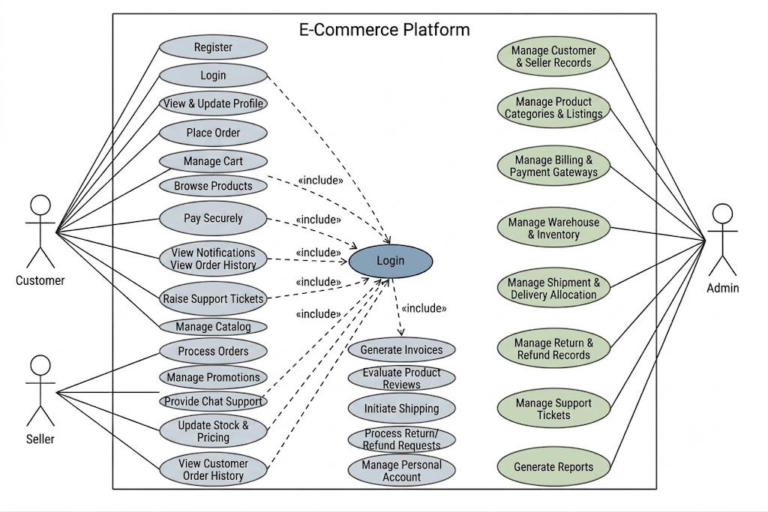

6. Implementation Strategy
Phase 1 -- Requirement Analysis
- Study existing e-commerce platform modules.
- Identify requirements of customers, sellers, administrators, and staff.
- Prepare SRS.
- Create use case diagrams.
- Identify analytics requirements.
Phase 2 -- System Design
- Design e-commerce database schema.
- Design analytics database.
- Design dashboard UI.
- Create UML diagrams.
- Design system architecture.
- Define data preprocessing workflow.
Phase 3 -- Development
E-Commerce Module Development
- Authentication
- Product Catalog and Search
- Cart and Checkout
- Order Management
- Billing and Payments
- Warehouse Inventory
- Customer Profile
- Feedback
- Return and Refund Management
Analytics Development
- Collect the three benchmark datasets.
- Clean the datasets.
- Handle missing values.
- Perform exploratory data analysis.
- Identify important features.
- Create charts and dashboards.
- Apply machine learning models.
- Compare analytical results across the three datasets.

7. Evaluation Strategy
Evaluation Parameter | Method
Functional Accuracy | Requirement verification
Performance | Load testing using JMeter
Security | Authentication and data-privacy testing
Reliability | System monitoring
Usability | Customer and seller feedback
Scalability | Concurrent user testing
Maintainability | Code review
Data Quality | Missing value and consistency analysis
Prediction Accuracy | Accuracy, Precision, Recall and F1-score
Analytics Performance | Comparison across three datasets
Dashboard Effectiveness | User evaluation

8. Expected Outcomes
- Centralized E-Commerce Management System.
- Easy access to shopping and administrative services.
- Improved order and delivery scheduling.
- Better customer purchase history tracking and personalized recommendations.
- Early identification of high-value and at-risk customers.
- Data-driven decision-making for business management.
- Analysis of both sales data and customer engagement behavior.
- Comparative evaluation using three benchmark datasets.
- Interactive analytics dashboards.
- Scalable architecture for future enhancements.

